CERTIFICADOS DE SOLOLEARN

PYTHON BASICO
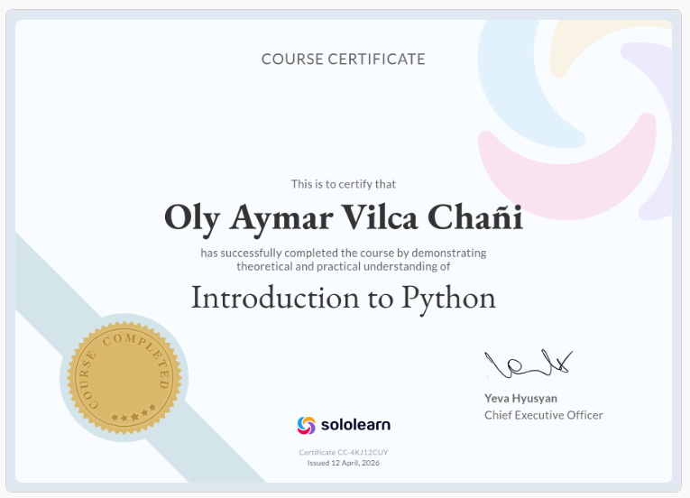
https://www.sololearn.com/certificates/CC-4KJ12CUY

PYTHON INTERMEDIO
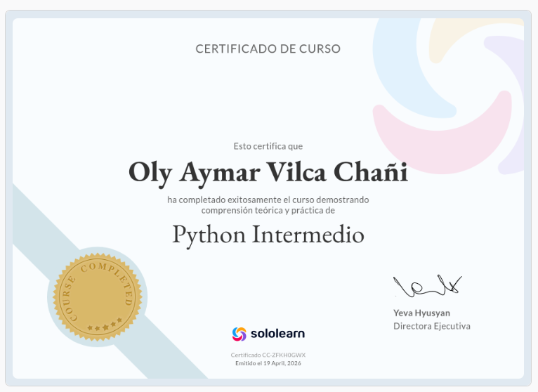
https://www.sololearn.com/certificates/CC-ZFKH0GWX

C++ BASICO
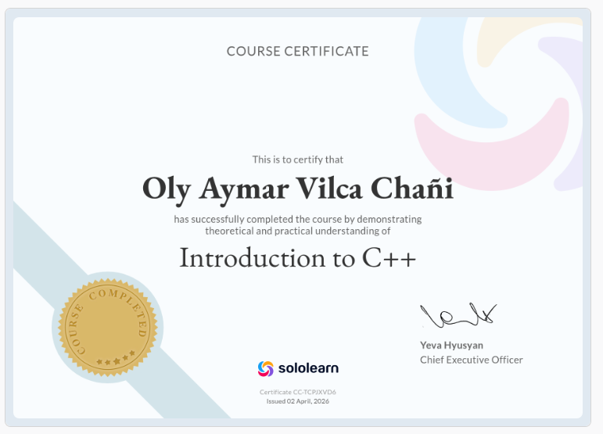
https://www.sololearn.com/certificates/CC-TCPJXVD6

C++ INTERMEDIO
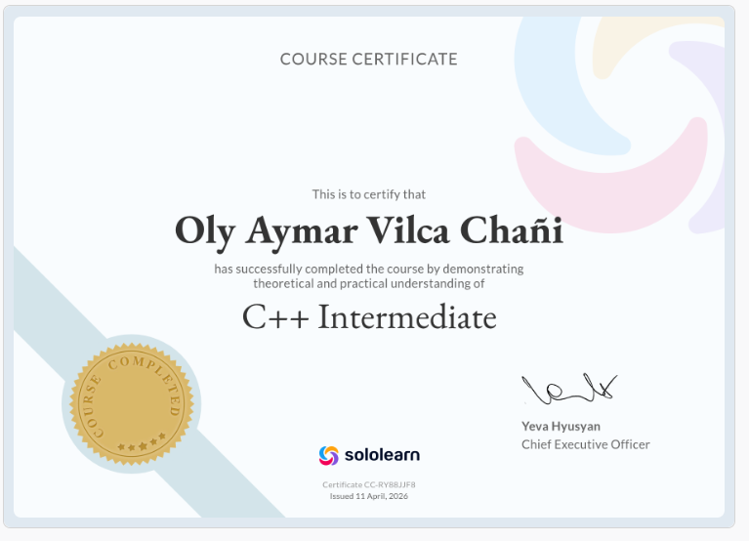
https://www.sololearn.com/certificates/CC-RY88JJF8

